**Breasts:** Pair of mammary glands

**Internal Anatomy**

1) Location: Anterior chest wall, superficial to the pectoralis major and serratus anterior. In

women, extends from 3rd to 6/7th rib vertically and sternal margin to the midaxillary line

horizontally.

2) Structure: Composed of glandular and fibrous tissue along with subcutaneous and retromammary fat. Proportion of each tissue depends on factors such as age, nutritional status, pregnancy, lactation and genetic predisposition.

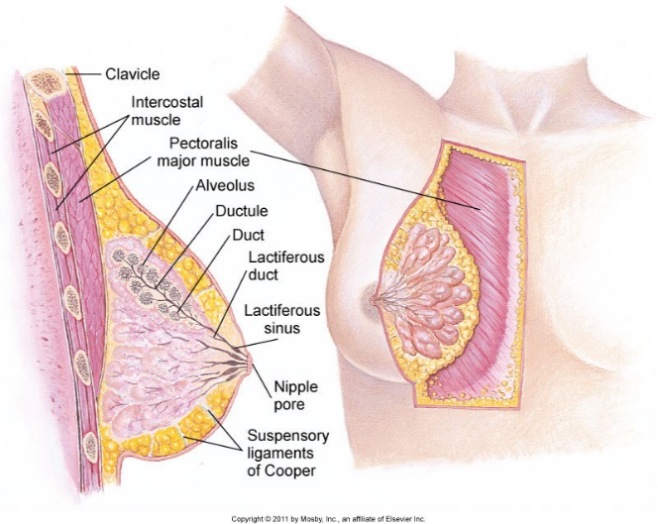-Glandular tissue is made of 15-20 lobes, which are each composed of 20-40 lobules, which are each composed of milk-producing acini cells (these cells are inconspicuous in nonpregnant, nonlactating women) that empty into lactiferous ducts

-Subcutaneous fibrous tissue-provides support for the breast. Composed of suspensory ligaments (Cooper’s ligaments) that extend from the connective tissue layer through breast and attach to the underlying muscle fascia. Muscles forming floor of breast include pectoralis major, pec minor, serratus anterior, latissimus dorsi, subscapularis, external oblique and rectus abdominis

-Subcutaneous and retromammary fat-surrounds glandular tissue; creates the bulk of the breast and gives the breast a soft consistency

3) Vascular supply: internal mammary artery and lateral thoracic artery

**External anatomy:**

-Nipple (central) is surrounded by pigmented areola. Nipple is composed of epithelium with infiltrated circular and longitudinal smooth muscle allowing for erection of the nipple and emptying of lactiferous ducts during contraction.

-Hair follicles located on the circumference of areola   
-Supernumerary nipples or breast tissue may be found along mammary ridge which extends from axilla to groin.

**Lymphatics:**

|  |  |  |
| --- | --- | --- |
| Lymph Drainage | | |
|  | Area of Breast | Drainage |
| Superficial lymphatics (skin) | Upper outer quadrant | Toward axillary nodes |
|  | Medial portion | Internal mammary chain toward opposite breast and abdomen |
| Deep lymphatics (drain mammary lobules) | Posterior chest wall | Posterior axillary nodes (subscapular) of the arm-located on lateral border of scapula and deep in posterior axillary fold |
|  | Anterior chest wall | Anterior axillary nodes (pectoral)-located along lower border of pec major, inside the lateral axillary fold |
|  | Upper arm | Lateral axillary nodes (brachial)-along upper humerus |
|  | Retroareolar | Interpectoral nodes to axillary chain |
| Other | Areola and Nipple | Midaxillary (high in axilla, close to ribs), infraclavicular and supraclavicular nodes. |

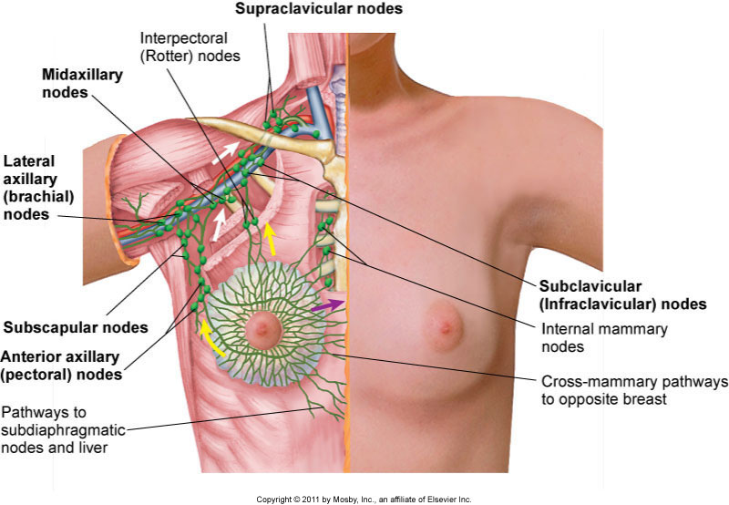

-Thelarche (breast development) represents first sign of puberty in girls.

-During pregnancy, changes include lactiferous duct proliferation, increase in alveoli (acini cells) size/number, 2-3 times increase in breast size, increased pigmentation and diameter of areola, more prominent nipples and engorgement of veins (may become visible as blue network beneath skin) due to increased vascularization.

-During first few days after delivery, colostrum is produced (contains protein, minerals, antibodies etc). Milk replaces colostrum 2-4 days after in response to increased prolactin, decreased estrogen and sucking stimulus which causes further breast engorgement.

-Following lactation, breast size decreases without loss of lobules or acinar cells.

-Post menopause->glandular atrophy->fat replacement and relaxation of suspensory ligaments ->breasts hang more loosely.

**History of Present Illness:**

|  |  |
| --- | --- |
| Complaint | Pertinent Information |
| Breast discomfort/pain | Temporal sequence: gradual vs sudden; duration; intermittent vs persistent  Relationship to menses: timing and severity  Character: stringing vs pulling vs burning vs stabbing vs aching vs throbbing; Unilateral vs bilateral; localized vs radiates  Associated symptoms: lump, mass, nipple discharge  Contributory factors: skin irritation, strenuous activity, recent nearby injury  Medications: hormones or oral contraceptive |
| Breast mass or lump | Temporal sequence: duration; relationship to menses; constant vs comes and goes.  Symptoms: Tenderness, pain, dimpling or change in contour of breast  Associated symptoms: nipple discharge or retraction; tender lymph nodes  Medications: hormones |
| Nipple discharge | Character: spontaneous vs provoked; unilateral vs bilateral; sudden vs gradual onset; duration; color, consistency, odor and amount  Associated symptoms: nipple retraction, lump or discomfort.  Associated factors: relationship to menses; recent injury to breast  Medications: hormones, oral contraceptives, phenothiazines, digitalis, diuretics, steroids |
| Breast enlargement in men | History of hyperthyroidism, testicular cancer, Klinefelter syndrome (XXY)  Medications: cimetidine, omeprazole, spironolactone, antiandrogens (finasteride), HIV medication, some antipsychotics, some antihypertensives, antiandrogen or GnRH prostate cancer treatment  Illicit drugs: anabolic steroids, marijuana |

**Physical Examination:**

Patient should be disrobed to the waste. Simultaneous exposure of both breasts is necessary to detect minor differences between them.

*Inspection:*

1. Inspect each breast and compare with other for size (often one is slightly smaller than the other), symmetry, contour, skin color, skin texture (should be smooth), venous pattern (more prominent in pregnant and obese), lesions, retractions/dimpling (signify contraction of fibrotic tissue that could be due to carcinoma),
2. Lift the breasts with fingertips, inspecting lower and lateral aspects.
3. Inspect areolae and nipples.
   1. Should be round or oval and symmetrical
   2. Color range from pink to black (nipples and areola should match in color).
   3. If inversion of nipple is noted, ask if this is a lifelong trait or recent change (recent unilateral inversion is suggestive of malignancy)
   4. Look for any nipple retraction (flattening/pulling back of nipple or areola suggestive of malignancy) or deviation
   5. There should not be any crusting, cracking or discharge.
   6. 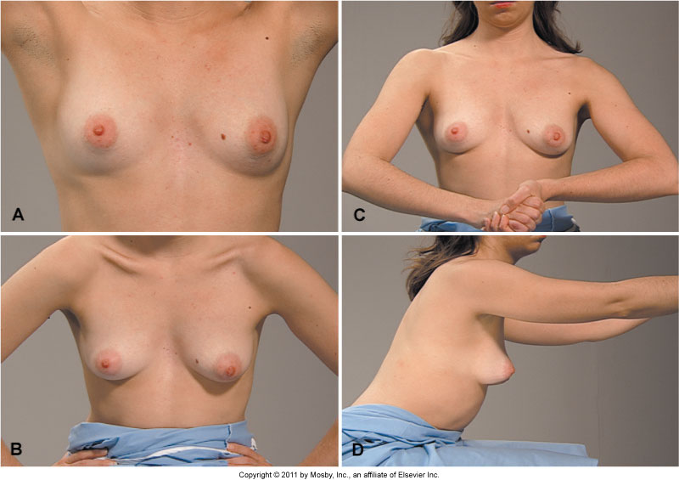Look for supernumerary nipples.

Re-inspect in varied positions:

1) Seated with arms overhead or flexed behind neck (accentuates dimpling)

2) Seated with hands pressed against hips with shoulders rolled forward

3) Seated and leaning forward from waist with arms extended out in front of body

*Palpation:*

Systematically palpate breasts, axillae, supraclavicular and infraclavicular regions.

Assess patient in both seated and supine position

Palpation with patient in seated position

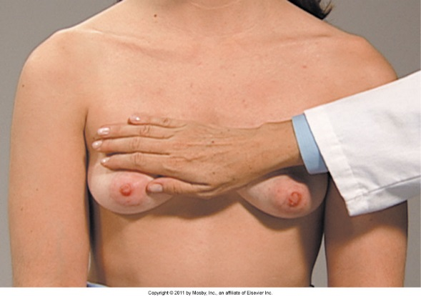1) Chest wall sweep- With palm of your hand, sweep from the clavicle to the nipple, covering area from sternum to midaxillary line.

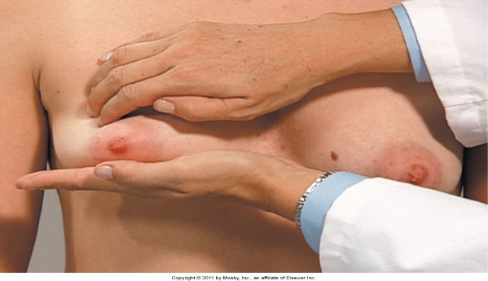

2) Bimanual digital palpation: Place palmar surface of hand under patient’s breast and with fingers of the other hand, walk across the breast tissue while compressing tissue between fingers and palmar surface of other hand. Feel for lumps.



3) Lymph node palpation: Support patient’s left arm with your left hand and use palmar surface of fingers on the right hand to push firmly into the axillary hollow. Palpate from apex downward to ribcage (reposition), into anterior wall along the pectoral muscles (reposition), posterior wall along scapula (reposition), also on the inner aspect of the upper arm down to the elbow. Repeat on other side.

Palpate supraclavicular and infraclavicular areas. Hook

fingers over clavicle into supraclavicular fossa and then in the infraclavicular area.

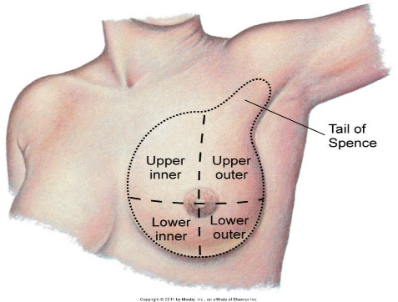

Patient in Supine position:

1. Have patient raise one arm behind head.
2. Palpate each breast separately. For purposes of examination divide breast into five segments, four quadrants and a tail (the greatest amount of glandular tissue lies in the upper outer quadrant, with breast tissue extending from this quadrant into axilla, forming the tail of Spence)
   1. Palpate using finger pads, pushing gently but firmly
   2. The exact sequence is not important but be systematic to ensure examination of all areas. Regardless of method avoid lifting fingers, but rather glide fingers.
      1. Vertical strip technique: Begin at the top of the breast and palpate downward, then upward, moving horizontally until entire breast is covered
      2. Concentric circle technique: Begin at outermost edge of breast tissue and spiral your way inward toward nipple
      3. 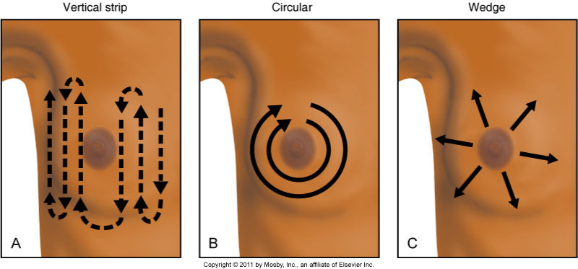Wedge method: Palpate from center in a radial fashion, returning to the areola to begin each spoke.

If breast mass if found, note location (clock position and distance from nipple), size, shape, consistency (firm, soft, hard), tenderness, mobility, borders (discrete vs poorly defined), and retraction.